## System architecture

Technology is changing day by day and it’s most important to use the perfect technology. From a business point of view technology can increase company profit, but also it can decrease a business image very quickly if is not addressed properly and if it’s something that requires a long time to reconstruct. As we are using the Microsoft SharePoint Online, it will help us to build the custom website in secure way and manage all of the information in same place. Below is the SharePoint Online Architecture diagram.

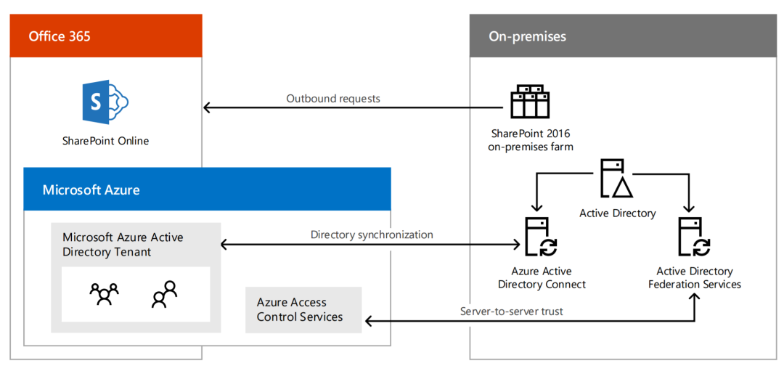

The system has been developed according to the SharePoint site structure. Below is the architecture for the website

SharePoint Site

News Site

Pages

News

Weather

Program of Schedule

Have Query

Query Form

Latest News